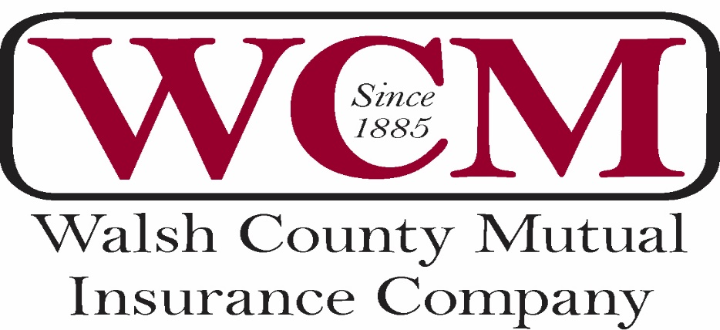

_____________________________________________________________________________________

*Homeowner’s Minto, N.D. 58261
*Farm & Ranch Brad Schanilec, Secretary & Treasurer
*Liability Phone: 701-248-3231

1

Annual Meeting Ballot
Absentee Voting
Yes______ No_______ I have read the minutes, from the annual meeting, shown on the Walsh County Mutual website and I cast my vote to accept them as presented.
Yes_____ No_____ I have read the financial statement on the website for the year 2020 and I cast my vote to accept them as presented.
Yes_____ The nominating committee has selected Ben Suda to succeed himself on the board of directors for another 3 year period.
Write in_______________________________________________

-------------------------------------------------------------------------------------------------------------

Proxy Voting
Yes_____ I authorize the Secretary of Walsh County Mutual Insurance Co. to cast a vote on my behalf.
-------------------------------------------------------------------------------------------------------------

Print your name__________________________________________________
Signature___________________________________ Date________________
Policy number if available_____________________________
-------------------------------------------------------------------------------------------------------------Please complete the absentee vote or the proxy vote. Do not do both.
Please visit https://www.walshcountymutual.com/annual-meeting-minutes-and-financials/ to read the minutes and financials from 2020. You may return your vote by email, “staff@walshcountymutual.com, fax “701-248-3709” or text “701-360-3615” Your participation on voting is GREATLY appreciated.
Brad Schanilec, Secretary

